REPORT ON
Comparative Study of SDLC Models for an Electric Vehicle Charging Network Management System
Submitted to
NMAM INSTITUTE OF TECHNOLOGY, NITTE
(Deemed to be University)

In partial fulfillment of the requirements for the award of the

Degree of Bachelor of Technology

By
Anmay S Nayak (NNM24IS032)

Submitted to
Dr. JASON ELROY MARTIS
Associate Professor
Department of ISE



Abstract
Software development for modern transport infrastructure demands systems to be capable of effectively integrating the physical and virtual worlds. This report includes an in-depth comparative analysis of the three key Software Development Life Cycle (SDLC) models. The models are the Waterfall Model, the Incremental Model, and the Spiral Model. This analysis is carried out from the perspective of an Electric Vehicle (EV) Charging Network Management System, which is a key technology in the rapidly expanding EV sector [1]. The main aim of the analysis is to compare the efficiency of each of the three models in managing the complex requirements of the EV sector in terms of both functionality and non-functionality. In addition, the analysis compares the efficiency of each model in managing the unique risks involved in hardware-software interaction. It also compares the efficiency of each model in managing the tight time constraints to achieve market share. Since the EV sector requires high availability systems with real-time data synchronization and seamless payment processing systems, the selection of the correct SDLC model is a key factor in gaining the trust of the end-users in the EV sector [2]. The analysis reveals that the Waterfall Model is not suitable for the rapidly changing EV sector. However, the Spiral Model is highly effective in managing the high-risk hardware integrations in the EV sector. The Incremental Model is the best model for the EV sector for the development of user-facing features such as real-time slot booking.
Introduction
Software engineering is not about coding. Software engineering is about using engineering to make software that works well. Can be used by many people. The Software Development Life Cycle is like a plan that helps us make software from the beginning until the end.
The Software Development Life Cycle has its own way of working. This is because all Software Development Life Cycle projects are different and have their own set of problems and risks. The Software Development Life Cycle has its own problems and risks, which could be technology-related or market-related. The Electric Vehicle sector is a fast-changing field and using a model that does not fit can be very bad. It can cause old technology to be used, which makes customers unhappy and it can also cause problems with hardware that's not useful anymore. This is particularly true for the Electric Vehicle sector. The Electric Vehicle sector is one of the industries that is growing quickly in the world. Because of this we need to build a lot of infrastructure to support the Electric Vehicle sector. An Electric Vehicle Charging Network Management System is not a simple app, on your phone. We are dealing with a complicated Internet of Things environment. The Internet of Things environment must let people book available charging slots in time. The Internet of Things environment must also be able to handle transactions.
The Internet of Things environment needs to be in touch with the hardware pedestals.
This means that the way we develop the Internet of Things environment has to be good at testing everything and it has to be able to handle a lot of users. The development approach has to be able to make updates all the time.
This report looks really closely at three models of the Software Development Life Cycle to see which one is best, for developing an Electric Vehicle charging network. The Electric Vehicle charging network is what we are focusing on. Special emphasis is placed on the requirements engineering and management phase. This is because the correct interpretation of the requirements for interoperability and performance is the foundation upon which a successful electric vehicle network is built.

GitHub Repository :- https://github.com/anmaynayak-del/ISE-Task-1

Overview of the EV Charging System Environment
We need an Electric Vehicle Charging Network Management System that can work well in a world where technology is changing very fast. This system has to keep up with what the customers want. Customers want to be able to find out away which charging points are available. They want to be able to book a charging point so they do not have to wait in line. They also want to be able to pay for the charging without having to use a lot of apps. The Electric Vehicle Charging Network Management System has to make all of this possible for the customers. The system has to handle an amount of data that is coming from thousands of hardware nodes that are connected to it. This data is coming in all the time. The system must be able to put all this data in a way that makes sense. It also has to make sure that the power is distributed in a way that does not overload the electrical grid [4].
The system is made up of different parts that all work together. These parts include the Centralised Charge Point Management System, which keeps track of the charge points in time and mobile apps that let people book a charging slot in real time. The Centralised Charge Point Management System and the mobile apps are parts of the system. The system also needs the software and hardware to work together. They use the Open Charge Point Protocol to do this. The Open Charge Point Protocol is what lets the software work with the hardware devices made by different companies. The system has different components, including the Centralised Charge Point Management System and the Open Charge Point Protocol. The system also needs to work with different payment systems. This includes things, like Unified Payment Interface (UPI) RFID or credit card transactions. These transactions are based on how much energy's being used at any given time. For example Unified Payment Interface (UPI) transactions can happen instantly when you use energy. The same thing can happen with RFID or credit card transactions. This is all based on the energy consumption metrics.
The mobile app has different parts and each part has its own technological needs. The system we use to make the mobile app must be able to control all the teams that work on it like the people who make mobile apps the people who work on IoT devices and the people who know about electrical grids. If the system fails, with payments or, with the hardware it can cause a lot of problems like damaging the batteries in vehicles causing financial problems and hurting the reputation of the company that runs the system. This is a deal because the market is very competitive and it is growing fast. The system operator has a lot to lose if something goes wrong with the app or the IoT devices or the electrical grid. The complex interplay of different components of the EV charging system makes it an ideal candidate for a comparative analysis of different SDLC methodologies.

Functional and Non-Functional Requirements
Functional Requirements (FR) :-
The functional requirements are the precise behaviours, actions, and features that the system needs to exhibit in order to meet the needs of the end-users and the system's operational requirements [6]. The first important functional requirement is Real-Time Charging Slot Booking (FR-01), which requires the system to enable the end-users to see the availability of the charging slots in real-time on the GPS map provided by the system, reserve the slots, and lock the hardware to ensure that the slots are not misused by other people before the end-users arrive at the site. The second important functional requirement is Hardware-Software Interaction and Session Control (FR-02), which requires the system to enable the end-users to start and stop the charging sessions remotely by sending OCPP messages to the hardware, monitor the state of charge of the vehicles and the internal battery temperature of the vehicles at all times. The third important functional requirement is Payment Integration and Automated Billing (FR-03), which requires the system to enable the end-users to calculate the exact bill based on the time taken or the exact quantity of electricity in the form of kWh used by the vehicles and deduct the bill from the digital wallets of the end-users. The fourth important functional requirement is Dynamic Load Management (FR-04), which requires the system to enable the end-users to manage the electrical power made available by the system to the multiple vehicles that are connected to the system at any point in time to avoid tripping the grid infrastructure.

Non-Functional Requirements (NFR) :-
Non-functional requirements describe the quality standards and constraints under which the charging network will operate. For High Availability (NFR-01), the core management servers will have to have at least 99.99% availability, utilising message queues and going offline to allow active charging sessions to finish even if the charging station momentarily loses Internet connectivity. For Scalability (NFR-02), the cloud-based setup will have to scale automatically to accommodate thousands of new charging stations and millions of active mobile app users as the electric vehicle market rapidly expands. For Hardware Interoperability (NFR-03), the backend will have to be able to parse data from any certified OCPP 1.6 and OCPP 2.0.1-compliant charging pedestals without any code modifications. Finally, to fulfil the requirement of Performance and Low Latency (NFR-04), updates to a charger’s status (e.g., from "Available" to "Charging") will have to appear on the user’s mobile map within two seconds to prevent double-booking.

Waterfall Model Analysis
The Waterfall Model is a way that people make software. It goes step by step. The Waterfall Model has steps: you figure out if you can do it then you make a list of what you need then you design the system then you build it then you test it then you put it out there and finally you take care of it. The main thing, about the Waterfall Model is that you have to finish one step before you can start the one. Okay before you move on to the next step of the Waterfall Model.
The Waterfall Model is good because it has a plan and people have to write down what they do. This is really helpful for the EV Charging Network project especially when we are planning where to put the charging stations and how to connect them to the power grid. We need to be careful when we work with high voltage electricity so it is good that the Waterfall Model makes us plan everything carefully before we start. The Waterfall Model is not so good when it comes to the computer systems that manage the charging network. The EV Charging Network project needs to be able to change and adapt. The Waterfall Model is bad, for the software part of the EV Charging Network project. The Electric Vehicle software user interface requirements are changing a lot and the Electric Vehicle software payment gateway requirements are getting more complicated by the month. When we are done with the design part of the Electric Vehicle software the Waterfall Model does not let us make changes easily which makes it hard to adjust if a competitor comes up with something, for their Electric Vehicle software.
The Waterfall Model is good because it helps us find the problems at the beginning of the Waterfall Model project. The problem, with the Waterfall Model is that if we need to make changes to the software-charger communication protocol later on it will cost a lot of money. This is because we make a plan at the start of the Waterfall Model and we do not change it. So the beginning of the Waterfall Model project takes a time to finish because we have to get everything just right with the Waterfall Model. Applying this traditional approach to the software management system of the EV Charging Network project will result in slow software development, giving the competitor an advantage in the market.[8]
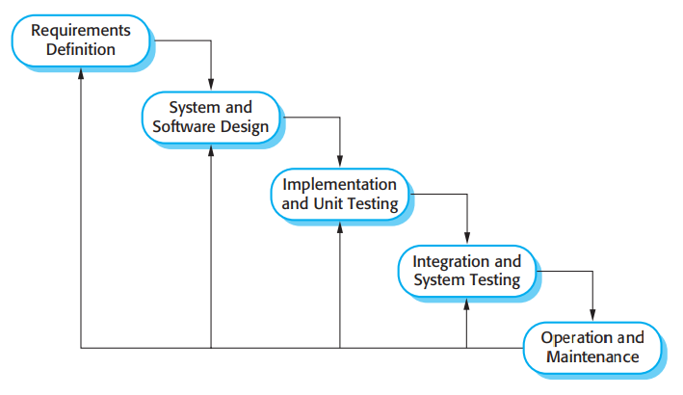[8]
Phase 1: Requirements
- First we will figure if the project is possible . Then we will write a list of what is needed (like the charging locations and the number of chargers and etc)
Phase 2: Software and System Design
- The we will plan how the system will look and work on paper. This is where we plan the “high voltage” Connections.
Phase 3: Implementation and unit Testing
- Then we create a hardware and the Software setup. Then it is tested to see if it works
Phase 4: Integration and System Testing
- Then we connect the software and the Hardware part . It’s very risky because fixing something at this point is very much expensive.
Phase 5: Operation & Maintenance
- Then the product is launched and if any bug or errors is occurred it is then corrected.

Incremental Model Analysis
The Incremental Model is a way of doing things. It does not try to make a huge system upgrade, at once. The big goals are split into parts that can work on their own. This means that the software is developed, built and tested one step at a time. With each release useful features are added. The Incremental Model keeps doing this until it creates the ecosystem [1].
The Electric Vehicle charging market is growing fast. It is not possible to make a system, for the whole world at the beginning. So the company can start with something. They can make an app that shows where the charging stations are. This will get some people to use it. Some will really like it. Then the company can make it better. Add a new feature that lets people book a charging spot when they need it. This way the Electric Vehicle charging system will get better and better over time. The company is thinking about adding payment systems to the next release. These new payment systems will include things like auto-deduct RFID wallets. They will also have route planning features.
The company wants to get people to use this first and then make it better over time. This way the company does not have to wait to release it. The company can release it now. Then add more features to the payment systems, like the RFID wallets and the smart route planning features later on.
The Incremental Model really helps to reduce the risk of the project going wrong. If something goes wrong like a bug it only affects the part of the project where the bug's. For example if a bug happens in a part of the user interface it will not stop the whole communication system from working.
The Incremental Model also makes it easy to make changes to the project. If users have trouble using the booking part of the system the developers can make it better in the part of the project. This way the Incremental Model is very flexible. Helps the developers to make the project better step by step. The Incremental Model is good because it helps to make sure the project is working well. It is easy to fix problems. The Incremental Model is useful, for the project. This model also provides strong control over project timelines and budgets. A company can make money from the first working set of chargers and use the revenue to add complex and sophisticated features for predictive maintenance [1].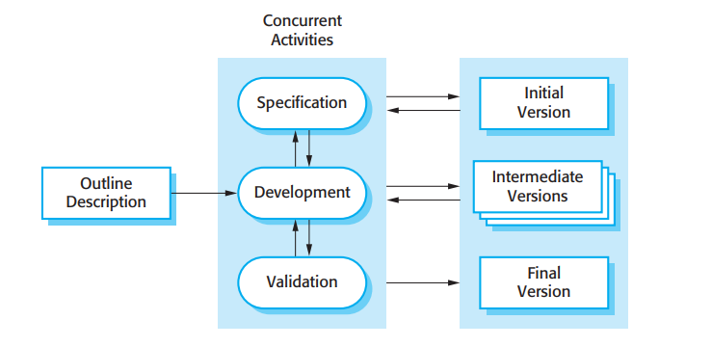[8]

Phase 1: The Rough Sketch (Big Idea)
What it is: A vague idea of what you want, even if you don’t have all the details worked out.
In the Report: The company wants a big “EV Charging Network,” but they don’t try to do it all at once. They start with what’s essential.
Phase 2: Parallel Work stream (The Engine)
Imagine the second box in our diagram. Instead of finishing a phase and then moving on, you do all three of these in a loop:
Specification (The Rules): Determine what exactly you’re putting in this update.
Development (The Build): Write the code for what you decided in specification.
Validation (The Check): Test it out to make sure it works.
Why the arrows go back and forth: If a problem occurs during Validation, you immediately go back to Development or Specification and fix it.
Phase 3: The Outputs (The Versions)
Initial Version:
In the Report: The first version of the program. Perhaps it’s a simple mobile app that will show users a map of charging stations. It’s not fancy, but it gets the job done.
Intermediate Versions:
In the Report: Next, you go through the cycle again, adding booking. Users can book a time slot. You did not re-make the map, you made it better by adding something else.

Final Version:
In the Report: Finally, you add in the advanced features like automatic payments and smart route planning. The program is complete.
Spiral Model Analysis
The Spiral model, in essence, is a risk-oriented approach to a project. It’s a combination of a prototyping approach and a Waterfall approach, progressing methodically in stages. There are four stages to this approach: defining your goals, evaluating the risks, developing, and reviewing your developments. What sets the Spiral model apart is its inclusion of risk analysis from the very beginning, even before coding or any hardware-related developments start. This is particularly important for systems such as an EV management system, where there is a great need for integration between the hardware and the software. If there’s a problem with either of these, it could have disastrous effects, causing costs to balloon and even threatening safety. In a sense, the Spiral model is a good approach for such systems, given its risk-oriented approach and its goal of mitigating risk. In a software development project for functions such as load balancing and power delivery, even a small error could have catastrophic effects, such as causing fires. Make batteries fail. So it is very important that we do a check for problems think about what could go wrong and test things out during each step of the development process. This is crucial for making sure that the software is safe to use and that peoples payments are secure before we let anyone use it. We need to do this with the development of firmware that controls dynamic load balancing and high-voltage power delivery to guarantee safety limits and secure payment gateways before releasing the firmware for public use and to avoid things, like electrical fires or battery failures with the firmware.
The Spiral model is really good at talking about risks and making sure they do not cause problems. It is very important that the Spiral model makes a working prototype and does penetration testing every time there is a development cycle. This helps to stop mistakes in the code from becoming big security issues. The Spiral model also helps with making changes. Thinks about testing the hardware when planning the next development cycle.. The big problem with the Spiral model is that it costs a lot of money and takes a long time. The Spiral model needs people who're very good at electronics and security to do a thorough risk analysis, for the Spiral model. The model is best suited for mission-critical backend systems where physical safety and financial accuracy are non-negotiable.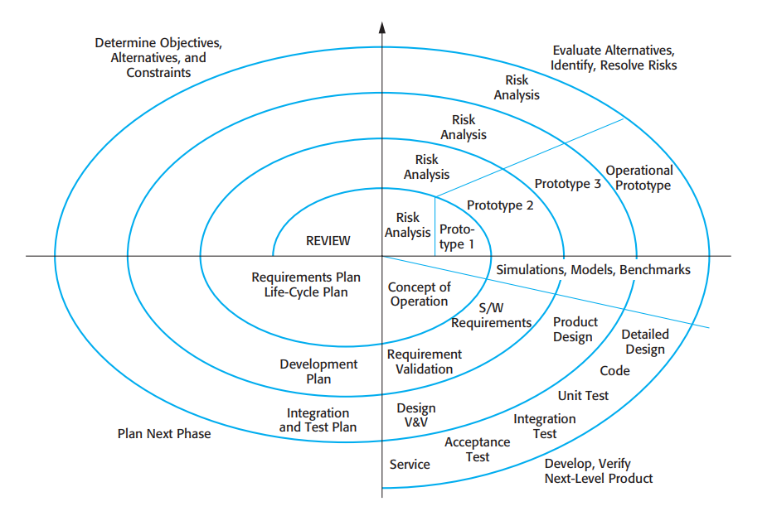[8]
Quadrant 1: Set the Goals (Top-Left)
Here, you define the goal you are trying to achieve, for example, “Our goal is to develop firmware that controls the voltage.” You should also define the constraints, for example, “It should not overheat.”
Quadrant 2: Assess Risks (Top-Right)
In this part, you define the risks of physical harm. You analyze the risks and dangers and think, “If I write the code like this, will the battery catch fire?”
Quadrant 3: Build and Verify (Bottom-Right)
You write the actual software for the charging of the electric vehicle and then test it to ensure the payment system works as required.

Quadrant 4: Plan the Next Phase (Bottom-Left)
You analyze what you accomplished in the first loop. If the first loop was about charging the battery, the next loop could be about billing.
Comparative Evaluation
As you balance these requirements, you will see that Waterfall will remain inflexible due to its fixed specs from the beginning. It will not be easily adaptable to new releases of EV model updates or changing consumer demands. However, Incremental will have some advantages in this regard, as we will be able to integrate new interface and feature updates, like subscription billing, in the next release. Spiral will be great for safety updates, where we will continue to refine and improve hardware architecture to accommodate new and evolving risk factors in power distribution.
As you review these options in terms of Risk Management, you will see that Waterfall will be at risk due to its fixed and inflexible approach. If a hardware incompatibility is not caught early, it will cost the company down the road. However, Incremental will have some advantages in this regard, as we will be able to compartmentalize and prevent a new feature, like a mobile app, from bringing down the entire session manager. Spiral is a good match for risk analysis. We'll continuously assess and improve our risk factors, and Spiral will be used to revamp a major IoT communication engine, where a programming error could have major repercussions.
If we consider these models in terms of our project’s Time to Market and Cost, it’s obvious that the Waterfall model takes much longer, only providing results at the end of the project. Again, this isn’t suitable for our rapidly changing world of Electric Vehicle updates and releases. On the other hand, the Incremental model excels for our consumer-facing aspects of the Electric Vehicle Charging Network, allowing our product to hit the market sooner and make a larger impact. Finally, the Spiral model, due to our hardware and prototyping requirements, will take longer and cost us more due to our hardware and software prototyping and safety considerations.
To sum it up, it really depends on the part of the Electric Vehicle Charging Network we’re discussing. For our groundwork and wiring, the Waterfall model is best. For our software platform, mobile app, and other software components, the Incremental model is best. Finally, for our riskier, integrated hardware and software components, such as load balancing and our cryptographic communication via the OCPP protocol, the Spiral model is best.
Requirements Validation and Management
Validating the EV charging network requirements carefully ensures that you land on something precise, unambiguous, and in perfect sync with what the users expect and what the hardware is capable of doing. Trying to deliver software features that the hardware is incapable of supporting is a huge waste of resources. This requires walkthroughs and sign-offs from both the software architects and the electrical engineers [2].

Challenges in Requirements Validation
A major issue is hardware fragmentation, which creates confusion about how hardware and software communicate with each other. For example, a standard like OCPP, even if implemented, can be interpreted differently by different hardware manufacturers about how to communicate using the protocols and their extensions. A software development team might validate a specific requirement, say, “Let’s show users the real-time temperature of a battery,” only to find out that half of the hardware platforms cannot even send a data packet for this specific feature.

Another issue is user experience without compromising the grid. Marketing might want a feature like “high rates, on-demand charging for our VIP users,” only for the software development team to have to explain why this would be a problem for stabilizing the grid during peak hours.
Another issue is edge-case validation for losing connectivity. Business needs might assume constant connectivity, but as a software development team, you have to validate a scenario where a user’s phone loses connectivity while their session is in a pause state, payment is still being made, and their car is being guided into an underground garage.
Lastly, there is scope creep, a classic nemesis of software development teams. The competitive nature of an electric vehicle charging business means that “nice-to-haves” like AI chatbots or V2G integration will inevitably be requested, threatening to derail development and cause a launch delay of the original features.
Limitations and Future Scope
This article will heavily rely on publicly available knowledge about modern IoT charging networks, the generalities of software engineering, and standard protocols like OCPP. While the inner workings of how these networks develop and the proprietary load-balancing algorithms used by the best networks, such as Tesla’s Supercharger network or ChargePoint, are highly guarded trade secrets, this article will discuss SDLC theories about a real-world cyber-physical system in a conceptual sense rather than an empirical sense of any one company’s inner workings.
Going forward, there are a lot of potential benefits to academic research that could come out of an expanded comparison to include DevOps and CI methodologies that are IoT device-specific, such as those about updating firmware over-the-air (OTA) for thousands of remote charging stations, and the software engineering impacts of shifting from traditional charging to bidirectional vehicle-to-grid (V2G) charging systems.

Conclusion
This report has taken a closer look at three different SDLC models: Waterfall, Incremental, and Spiral, and weighed their suitability to the scale, hardware requirements, and real-time needs associated with running an Electric Vehicle Charging Network. It has also highlighted how Waterfall is suitable for initial stages, such as civil and electrical planning, but its inflexibility is a disadvantage when considering the dynamic needs that a rapidly evolving electric vehicle market might require. On the other hand, Spiral excels at risk analysis and is therefore highly recommended for critical integrations that require high-voltage hardware and/or critical financial flows.
In conclusion, while integrating hardware and software requirements that require real-time responses, such as slot booking, payment integrations, and the dynamic interplay between hardware and software, a critical integration would require a strategic integration of Incremental development with Spiral analysis. The most successful Electric Vehicle Charging Network would therefore require Incremental development to ensure a smooth user interface while incorporating Spiral analysis for critical hardware integrations.

References
[1] GeeksforGeeks. "Incremental Process Model Software Engineering." GeeksforGeeks, 28 May 2018, www.geeksforgeeks.org/software-engineering/software-engineering-incremental-process-model/.
[2] Sommerville, Ian. Software Engineering. 10th ed., Pearson, 2015.
[3] Meegle. "Waterfall Methodology Failures." Meegle.com, 2025, www.meegle.com/en_us/topics/waterfall-methodology/waterfall-methodology-failures.
[4] NITI Aayog. "Electric Vehicle Charging Infrastructure Implementation." Government of India, 2023, www.niti.gov.in/sites/default/files/2023-02/EV_Handbook_Final_14Oct.pdf.
[5] eInfochips. "Exploring the Architecture of Electric Vehicle Charging and OCPP Protocols." eInfochips Blog, 2025, www.einfochips.com/blog/exploring-the-architecture-of-electric-vehicle-charging-and-ocpp-protocols/.
[6] Pulse Energy. "Create an Efficient Payment System for EV Charging to Enhance User Experience in India." Pulse Energy Blog, 2025, pulseenergy.io/blog/payment-system-for-ev-charging.
[7] Talreja, Abhay. "Spiral Model vs Waterfall Model: Choosing the Right SDLC Approach for Highly Secure Projects." Teaching Agile, 12 July 2025, teachingagile.com/sdlc/comparisons/spiral-vs-waterfall.
[8] Sommerville, I. Software Engineering. Pearson Education.

